Chapter 19, Problem 78.

Obtain the h parameters at ω = 4 rad/s for the circuit in Fig. 19.124 using PSpice.

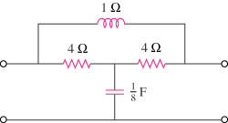

Figure 19.124
For Prob. 19.78.

